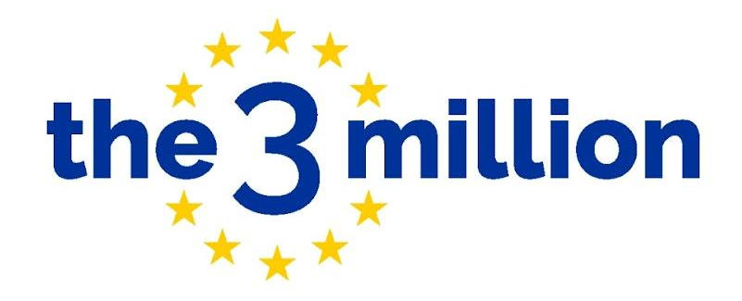

Briefing Document:

Mass Lobby on EU Citizens’ Rights
WHAT IS A MASS LOBBY?
A mass lobby is when a large group of people come to Parliament at the same time to speak to their MP about an issue. On 23rd June 2026, the 10th anniversary of the Brexit referendum, people will come to Parliament from across the country to tell MPs that they must demand the government address the severe flaws and injustices within the post-Brexit EU Settlement Scheme (EUSS).
HOW?
Everyone who is attending must register their attendance for the mass lobby. You then need to email your MP to let them know you are coming to Parliament and would like to meet. You can find the template letter here. We will meet at Victoria Tower Gardens South (Abingdon St, Millbank, London SW1P 3JA) by 11.30am to share information, take a group photo and begin to enter Parliament at 12pm. When you arrive in Parliament, either your MP will have responded to arrange a meeting time, or you can submit a green card to see your MP. We cannot guarantee your MP will be there, but you can at least pass a message to your MP’s Parliamentary Assistant about why you have come and your MP is expected to reply in writing to let you know their views on the matter.

You can use this briefing document to prepare for your conversation with your MP and we will provide you with information you can hand to your MP so they know our concrete asks. If there are other people in your constituency coming, we’ll let you know so you can see your MP together. If you are coming from an organisation, you can either meet with your own MP or the one for your organisation’s HQ.

More details will be shared via two identical online information sessions:
- Wednesday 10th June 2026, 6pm - 7.15pm via Zoom
- Tuesday 16th June 2026, 6pm - 7.15pm via Zoom

WHY?
The EU Settlement Scheme (EUSS) is failing the over 5.7 million people who applied. Thousands, including children, the elderly, and vulnerable adults remain excluded. Barriers include difficulty with late applications, lengthy periods in limbo - unable to travel - while waiting for decisions, and lack of assistance since all support for Government Funded Organisations (GFOs) ceased after March 2026. For those who have been able to get their EUSS status, the lack of tangible proof of status causes a huge range of problems across travel, employment, rental, healthcare, benefits and more. Pre-settled status is particularly fragile, disproportionately impacting those with low digital literacy or difficulty proving residence. Reliance on digital-only status affects work, housing, healthcare, driving licences and travel. It creates barriers with agencies like the DVLA, HMRC, DWP and NHS due to data errors and a lack of in-person help. This issue is critical: the injustices and systematic failures EU citizens face now affect all migrants as the UK has rolled out its digital-only status to 10 million people, and is planning to introduce digital ID also for British citizens. We must demand a fair and just system for all, a system that delivers the rights we were promised.
WHO CAN COME TO THE MASS LOBBY?
EVERYONE! It is essential that your voice is heard on this matter. Bring your friends, your family, your neighbours. The more, the merrier - ensure everyone has signed up here.

Children are welcome. If you do choose to bring your children, you will be responsible for them throughout the event. In Parliament, there are baby changing facilities but no dedicated breastfeeding space. We are unable to provide childcare facilities on the day.

UK Parliament is accessible for wheelchair users and there is step-free access. More information can be found here.

IS THERE SUPPORT TO GET ME THERE?

Unfortunately, we are not in a position to provide funding to support people’s travel. If you are unable to attend the mass lobby then please register here instead to arrange a local constituent’s meeting with your MP.

HOW CAN I PREPARE FOR THE MASS LOBBY?
- Familiarise yourself with the information contained in this briefing document.
- Make sure you email your MP to invite them for a meeting on the day of the mass lobby using our template letter here.
- Join one of our briefing calls taking place on either Wednesday 10th June or Tuesday 16th June (between 6pm - 7.15pm) for the final event logistics on 23rd June.
- Join our WhatsApp chat for live updates.

WHAT SHOULD I WEAR AND BRING WITH ME?
There is no dress code, but we recommend dressing smart/casual and wearing comfortable shoes. No banners, badges, or t-shirts with slogans are permitted. Bring a small bag to make security as easy as possible and you may wish to bring an umbrella in case it is raining while we wait outside.
SAFETY AND SECURITY CONCERNS:

Key things to know at this point are:
- Any member of the public can enter Parliament.
- You do NOT need to present your I.D. nor share your immigration status with anyone in Parliament, including security.
- You have to go through airport-style security in order to enter Parliament.
If you do not want your photos taken, be sure to let the3million staff know and we will provide you with a sticker to ensure it is clear that you have not given photo consent. We kindly ask that when you take your own photos, you avoid capturing other people in them who have not consented.

